Payload Encryption (JWE) configuration

Specification v1.0, November 2022

Contents

Version History 3
Glossary of acronyms 4
1. Introduction 5
2. Purpose of this document 5
3. Creating a new Payload Encryption (JWE) configuration 5

Version History
Ver. | Comment | Name | Date
1.0 | Initial version | Victor Harrison | November 04, 2022

Introduction
Using encryption JWE the SCG platform allows the configuration of encryption for the payloads sent previously configured in the Event Manager session.

Purpose of this document

Provide knowledge about the possibility of encryption as well as explaining step by step how to perform this configuration.

Creating a new Payload Encryption (JWE) configuration
- Click on the gear menu next to the delivery configuration item you wish to add a Payload Encryption (JWE) Configuration. If you do not have any delivery configurations see Adding a New Delivery Configuration.

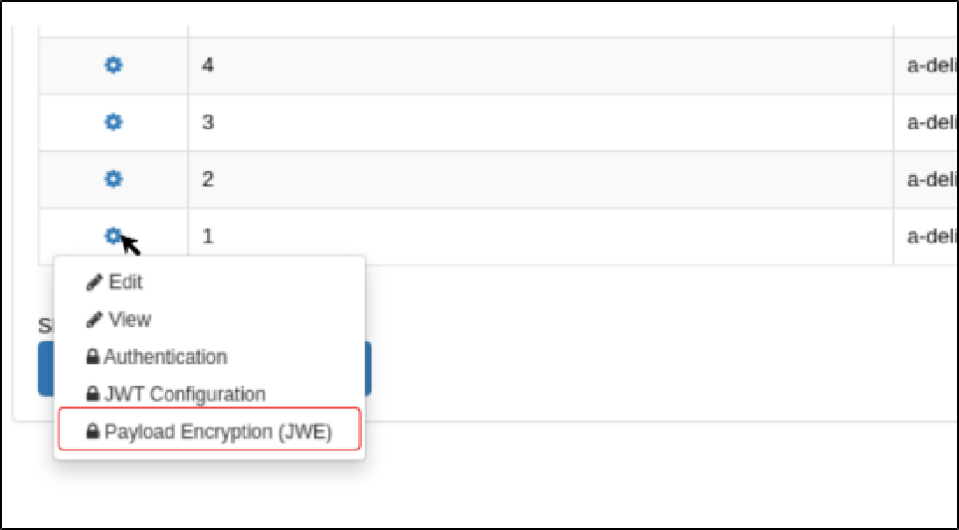

- Click on Payload Encryption (JWE)

If you have not previously created a Payload Encryption (JWE) configuration the configuration form will be switched off, otherwise, it will show and allow you to edit your configuration.
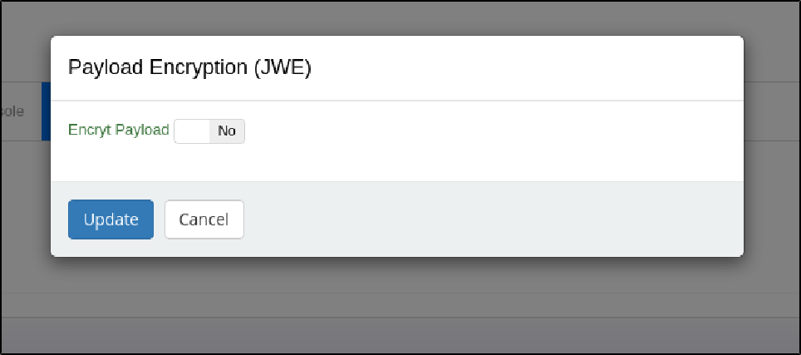
- Enable the Payload Encryption (JWE) by clicking on the Encrypt Payload switch and enter the required fields. JWK URL is required to save the configuration.
JWT JOSE Headers and JWK Optional Headers are optional.

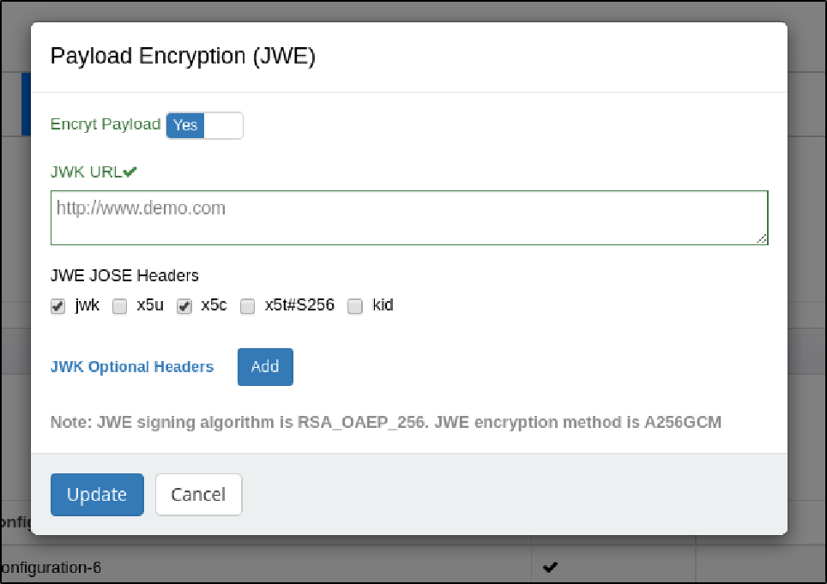
- JWK Optional Headers may be added by clicking the Add button. JWK Optional Headers may be removed by clicking the trash icon.
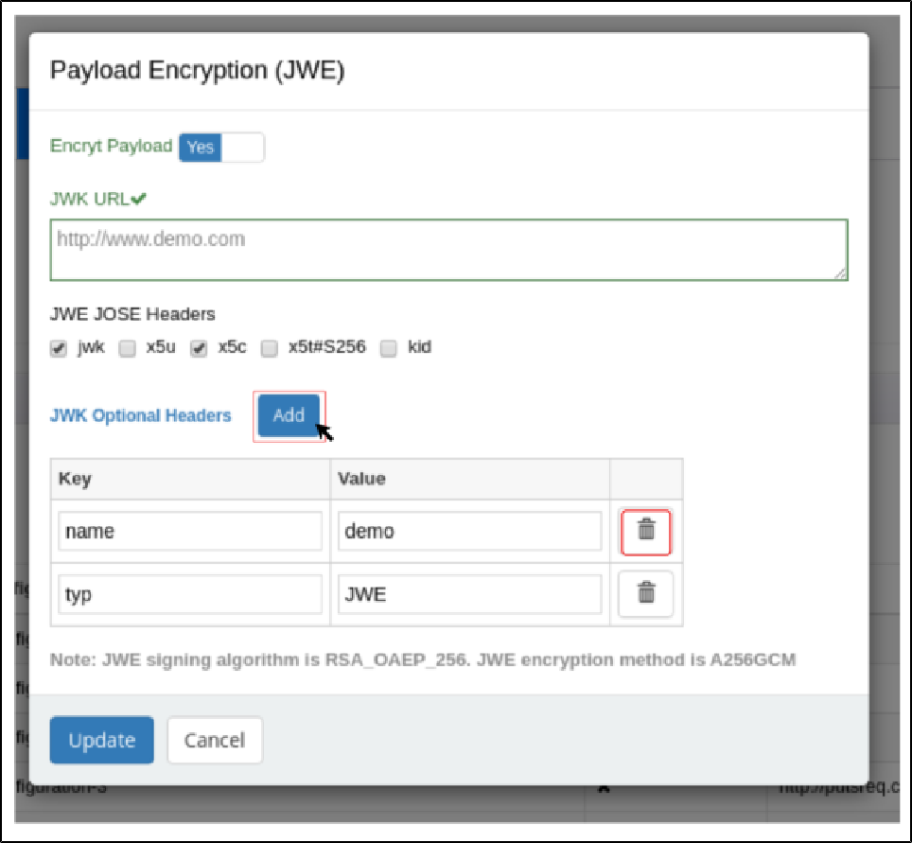

- After you have completed editing the form, Click Update to save your changes.

About Syniverse
Syniverse is the world’s most connected company—we pioneer innovations that take businesses further.
Our secure, global network reaches billions of people and devices. Our engagement platform powers the customized experiences of the future. And the millions of secure transactions we drive every minute are revolutionizing how goods and services are exchanged. We have always led companies to reimagine the boundaries of possibility. Today we’re delivering on opportunities with the power to change the world. www.syniverse.com

